**Simple Linear Regression**

* y= mx +c

y-> Dependent variable

x-> Independent variable

We have to find two parts of the model m and c

* In simple Linear Regression, we do not need to apply feature scaling the library is going to take care for that
* Once we get the predicted model parameters, if we need to plot the line, it does not matters if we are plotting the x_train with predicted values of x_train or we are plotting x_test with predicted values of x_test. The result will be the same.
* plt.scatter will create scattered points all over the graph.
* The above point is confirmed from this line
* 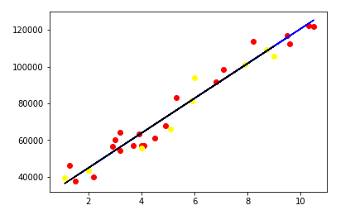
* Important Points to Note- dataset.iloc gives the cell positions to find out in the format [row, col] where we give row and col in integers
* Dataset.loc gives the cell positions to find out in the format [row,col] where we give row and col names
* Also another point to note here dataset[:,:-1] gives the raw data only. In order to convert it to form that we can use in our mode(in numpy values) we use dataset[:,:-1].values